Instructions for authors

Gheorghe I. Popescu

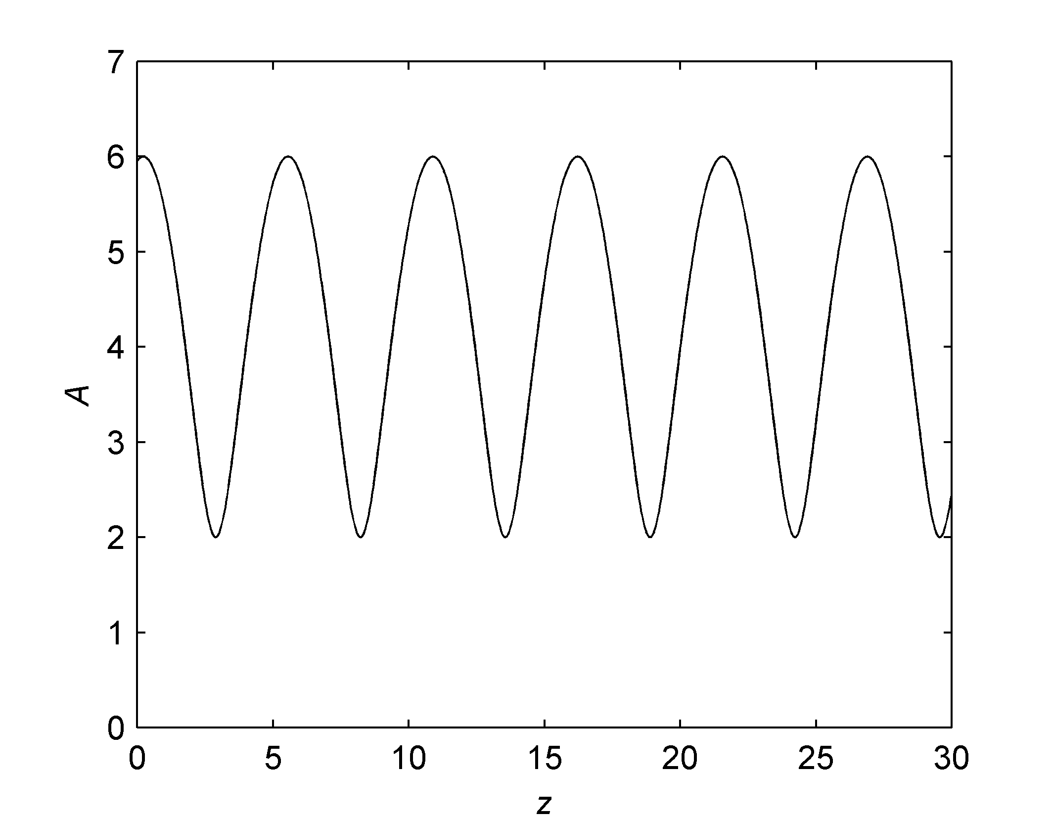
Abstract – These instructions present a model for editing the papers accepted at the Symposium DrETC09. The abstract should contain the description of the problem, methods, solutions and results in a maximum of 12 lines. No references are allowed here.
Fig. 1. Amplitudes in the standing wave
Keywords: editing, author

I. INTRODUCTION

The page format is A4. The articles must be of 6 pages or less, tables and figures included.

II. GUIDELINES

The paper should be sent in this standard form. Use a good quality printer, and print on a single face of the sheet. Use a double column format with 0.5 cm in between columns, on an A4, portrait oriented, standard size. The top and bottom margins should be of 2.28 cm, and the left and right margins of 2.54 cm. Microsoft Word™ for Windows is recommended as a text editor. Choose Times New Roman fonts, and single spaced lines. Font sizes should be: 18 pt bold for the paper title, 12 pt for the author(s), 9 pt bold for the abstract and keywords, 10 pt capitals for the section titles, 10 pt italic for the subsection titles; distance between section numbers and titles should be of 0.25 cm; use 10 pt for the normal text, 8 pt for affiliation, footnotes, figure captions, and references.

III. FIGURES AND TABLES

Figures should be centered, and tables should be left aligned, and should be placed after the first reference in the text. Use abbreviations such as “Fig.1.” even at the beginning of the sentence. Leave an empty line before and after equations. Equation numbering should be simple: (1), (2), (3) … and right aligned:

$x(t)=\int{y(τ−t)dτ}$. (16)

IV. ABOUT REFERENCES

References should be numbered in a simple form [1], [2], [3]…, and quoted accordingly [1]. References are not allowed in footnotes. It is recommended to mention all authors; “et al.” should be used only for more than 6 authors.

Table 1
Parameter | Value | Unit
I | 2.4 | A
U | 10.0 | V

V. REMARKS

- Abbreviations and acronyms

Abbreviations and acronyms should be explained when they appear for the first time in the text. Abbreviations such as IEEE, IEE, SI, MKS, CGS, ac, dc and rms need no further explanation. It is recommended not to use abbreviations in section or subsection titles.

- Further recommendations

The International System of units is recommended. Do not mix SI and CGS. Roman section numbering is optional.

REFERENCES

[1] A. Ignea, “Preparation of papers for the International Symposium Etc. ’98”, Buletinul Universităţii “Politehnica”, Seria Electrotehnica, Electronica si Telecomunicatii, Tom 43 (57), 1998, Fascicola 1, 1998, pp. 81.
[2] R. E. Collin, Foundations for Microwave Engineering, Second Edition, McGraw-Hill, Inc., 1992.
[3] http://www.etc.utt.ro/html/conferinte%202002.htm

Facultatea de Electronică şi Telecomunicaţii, Departamentul Comunicaţii Bd. V. Pârvan Nr. 2, 300223 Timişoara, e-mail geo@etc.utt.ro

