Section 2.YYY

DxDesigner integration with HyperLynx Analog
This exercise will walk you through the process of simulating with HyperLynx Analog. Assigning simulation models to components, and running DC, transient, and AC simulations.

Simulating circuits prior to or concurrently with pcb design ensures the circuit works right the first time by eliminating wiring and polarity errors. HyperLynx Analog is easy to use, fast to setup and no longer requires library preparation.

For a video demo, using a similar circuit for the features in this lab and more, see:
http://www.mentor.com/products/pcb-system-design/multimedia/better-pcb-analog-design-webinar

2.YYY.1 HyperLynx Analog
DxDesigner HyperLynx Analog can simulate your PCB circuits.
This section will allow the user to use the simulation capabilities of HyperLynx Analog.
- In DxDesigner Select File\Open\Project and select C:\DxEvaluation\LessonYYY\LessonYYY.prj.
- Using the DxDesigner menu, turn on the licensing for HyperLynx Analog
  - Setup >Licensing >HyperLynx Analog and Press OK
  - The HyperLynx Analog toolbar should appear. If not use the DxDesigner Menu, View >Toolbars >HLA Simulation.

- Using the LMB, double click on ‘Inst_Amp’ in the Navigator Block Section
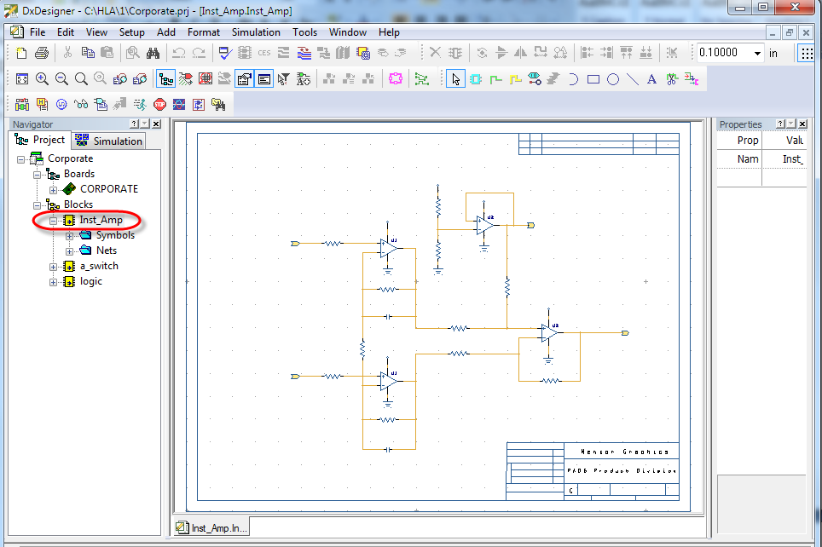
- Click the Testbench Options icon, the leftmost Icon in the HyperLynx Analog toolbar.
  - In Testbench Options: Inst_Amp dialog select the HyperLynx Analog radio button and OK
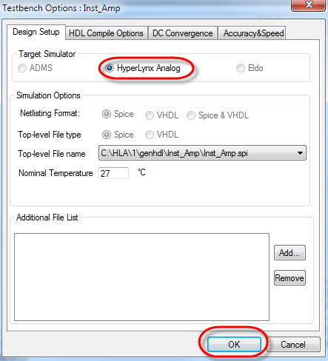
- This step is optional for a demo, if you have time constraints, it has been completed.
The passive components have had SPICE properties added. but if the properties are not in a library, it is easy to add the SPICE properties to the capacitors C1 and C2. Select C1 and RMB on the symbols and select Simulation Model Properties to view that a model is assigned as Built In (Spice). C2
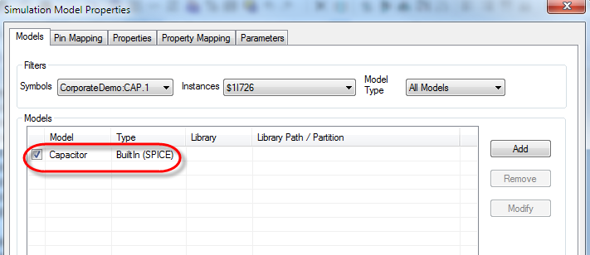

  - While C1 is still selected verify Select the Capacitors and in the Properties Window, verify Order=VALUE$ and VALUE=0.22u
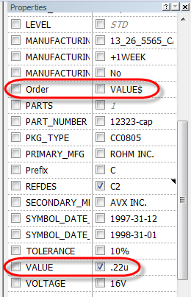

- This step is optional for a demo, if you have time constraints, it has been completed.
Next add the SPICE properties to the Op Amp. Go to www.analog.com, search for ad8638 spice and download the SPICE model (a copy AD8638.cir is in the project directory)
  - Next from the DxDesigner Menu, Tools Convert PSPICE libraries, and select the downloaded file. The file AD8638.cir has been saved in the project directory.
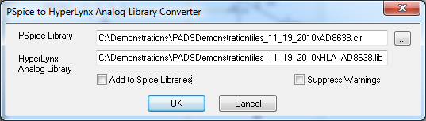This converts the file to one with an HLA prefix, and .lib suffix
  - Select the first OPAMP and RMB Simulation Model Dialog,
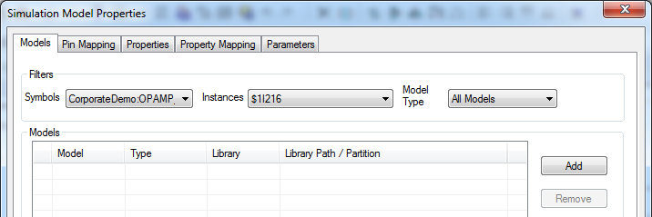
Continuing on adding the SPICE properties to the op amp…
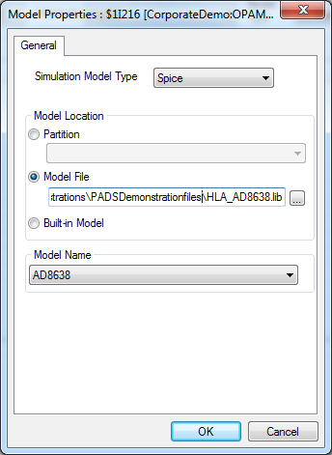
Select SPICE from the dropdown
Select the Radio Button, Model File
Browse to the converted model file, HLA_AD8638.lib

Select AD8638
Press OK, to close Model Properties, but stay in the Simulation Model Properties dialog as shown below:
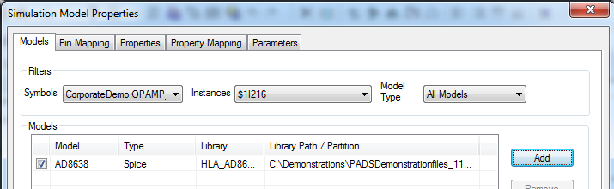
Continuing on adding the SPICE properties to the op amp…
Select the Pin Mapping tab, and then View Model Button, and arrange it to see the pin numbers.
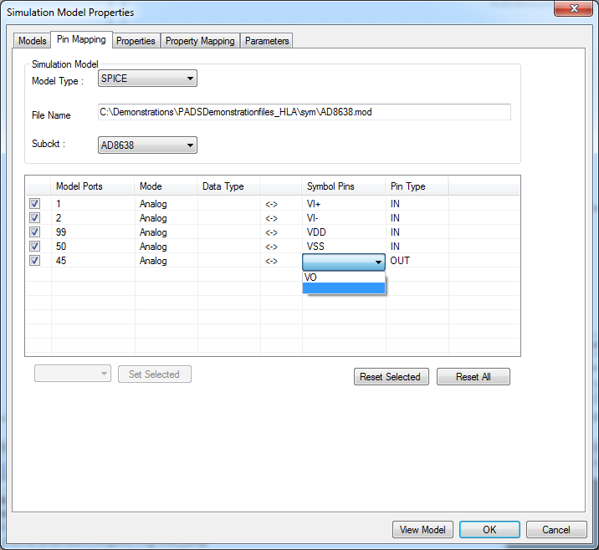
Unselect incorrect items to create a list.
Select the correct pinout from the list.
Press OK when finished
For the remaining 3 OPAMPS reopen on each the Spice Model Properties. The pin assignment changes made for the first opamp will be cached. Simply RMB on the opamp symbol, select Spice Model Properties and Press OK to attach the model to the symbol.
Select all 4 opamps, and verify the properties, especially the Order property
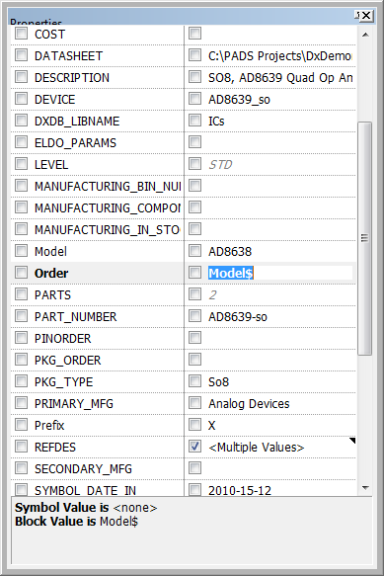
Verify this property
Order=Model$
- This step is optional for a demo, if you have time constraints, it has been completed. Simply open the source dialog to show how sources can be prepared
Next it is time to setup the signal sources, this is done using by activating the sources Icon.

Add 2 DC sources
Add VDD as a DC source at 10V with input nodes of PWR and 0, 0 is the GND node.
Add Offset as a DC source at 5V with input nodes of NEG_INPUT and 0
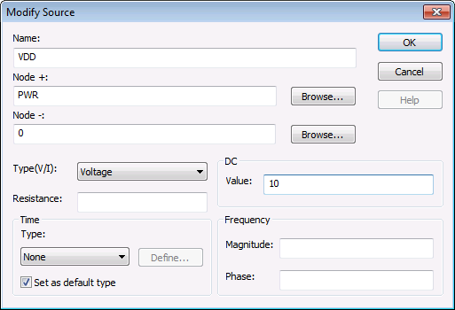
The result should look like this in the sources dialog
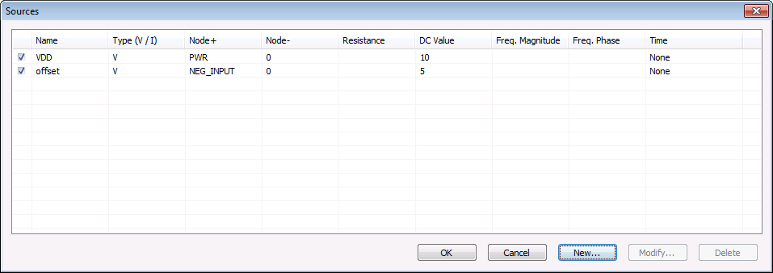
  - Add a third source, this will be a combination source with DC, AC and Transient properties
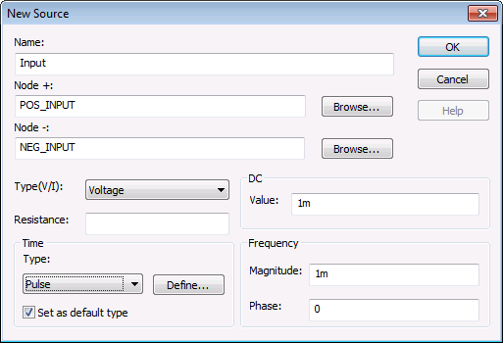
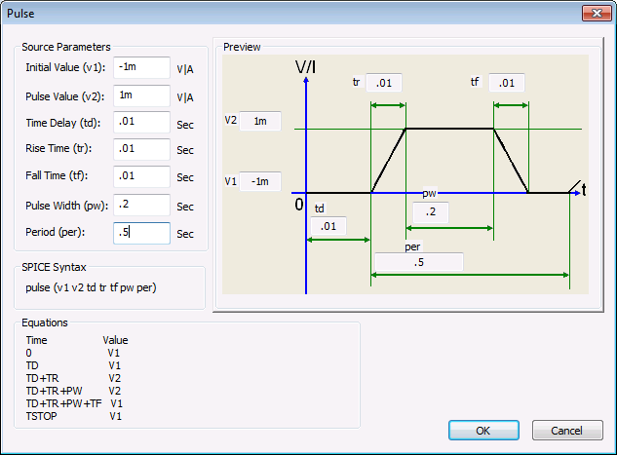
  - The completed source dialog should look like this:
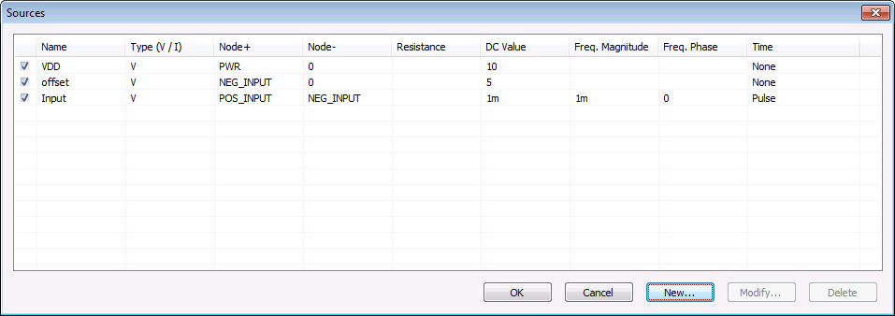

- The final setup step is to edit the simulation dialog by pressing simulate design
  - 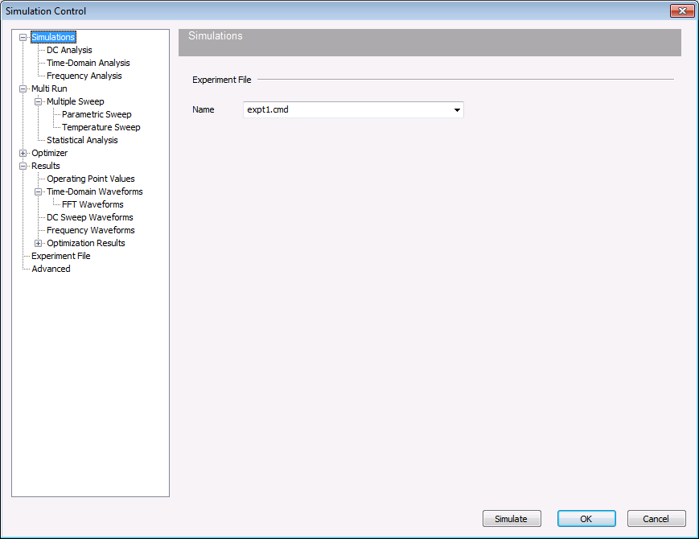
  - 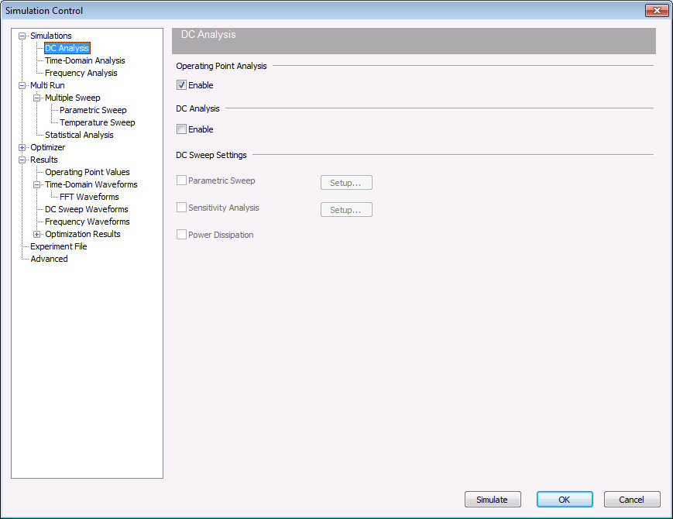
  - 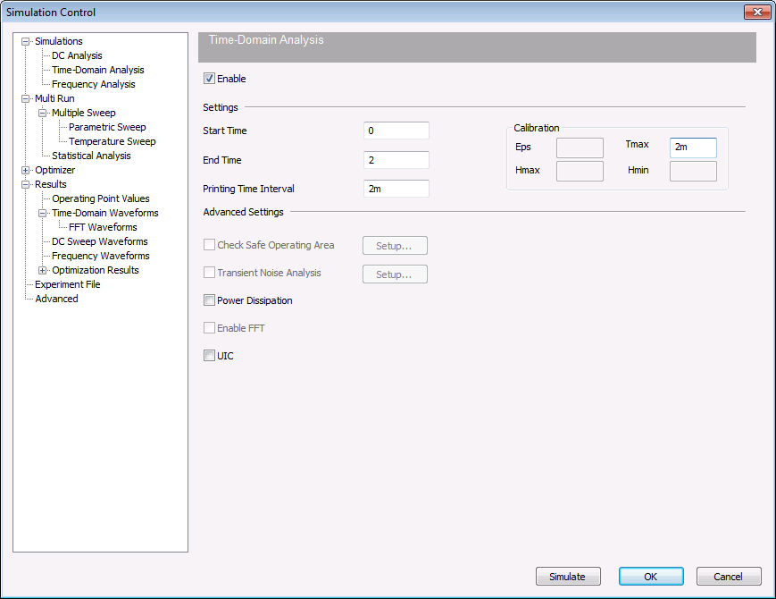
  - 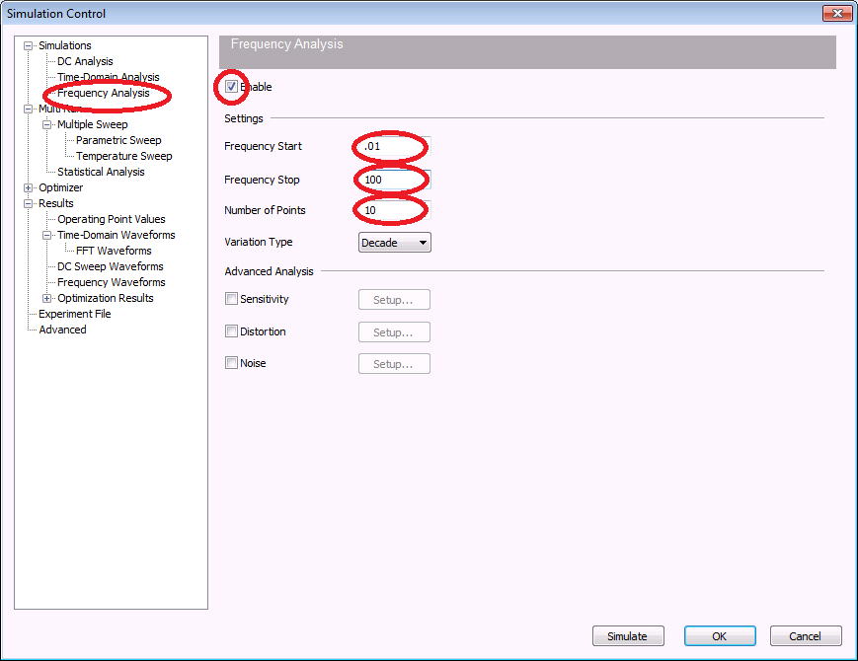
  - 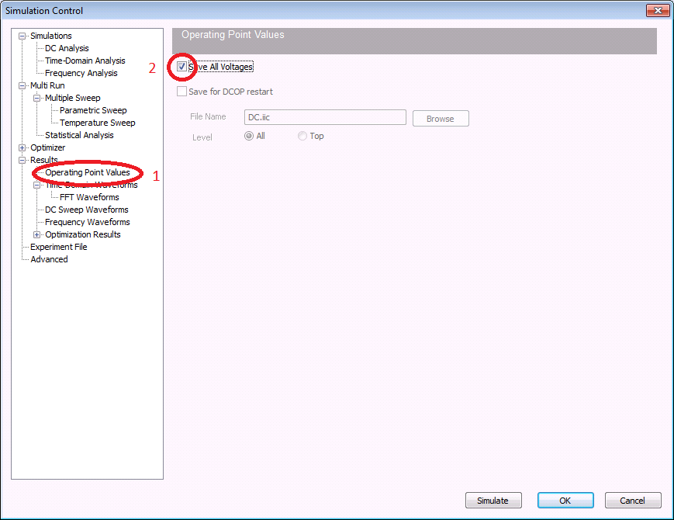
  - Press Simulate
- Review the results in the output window
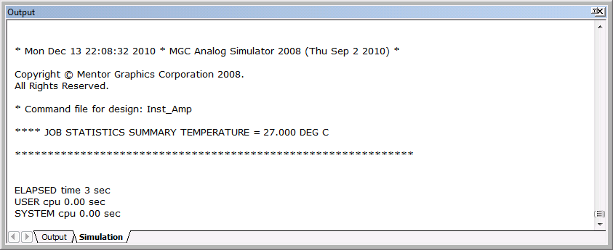
- Show the Back annotation on the schematic by
  - LMB click the schematic window, to make it the active window.
  - LMB click the Show Back annotation icon shown above
  - LMB click on schematic again.
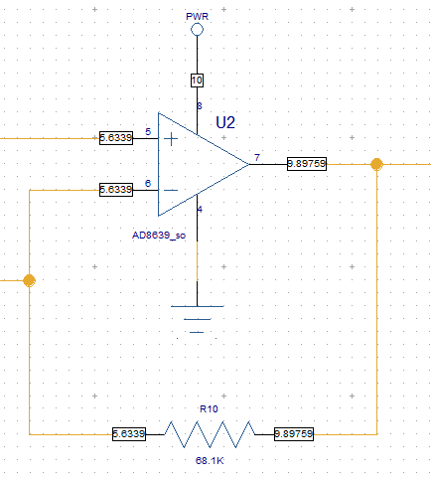
- When simulation completes, EZWave opens automatically, it can also be opened with the toolbar
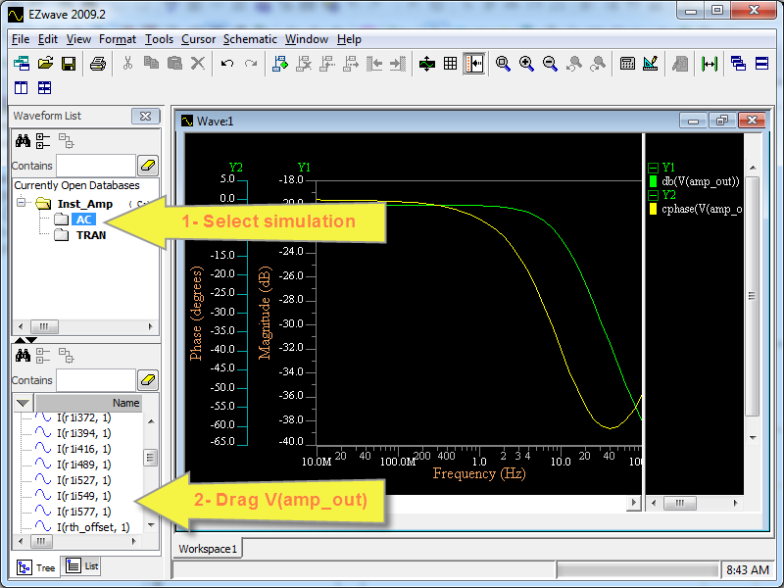
  - Select AC to show the waveform names in the lower left window pane and drag V(amp_out) onto the workspace to view the AC results.
- Select TRAN to show the transient waveform results and drag (Vamp_out) next to Workspace1 to create a new Transient waveform window 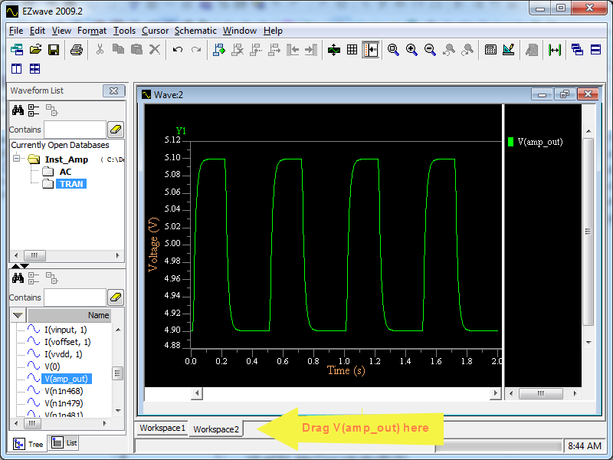
- Use the Measurement tool, Tools Measurement to find the Peak to Peak voltage and the frequency.
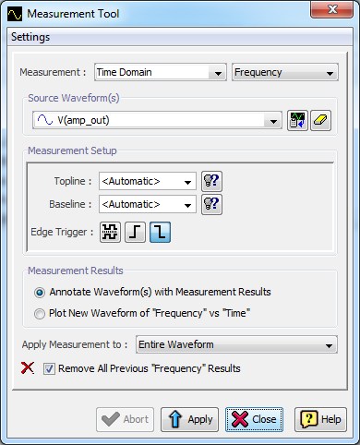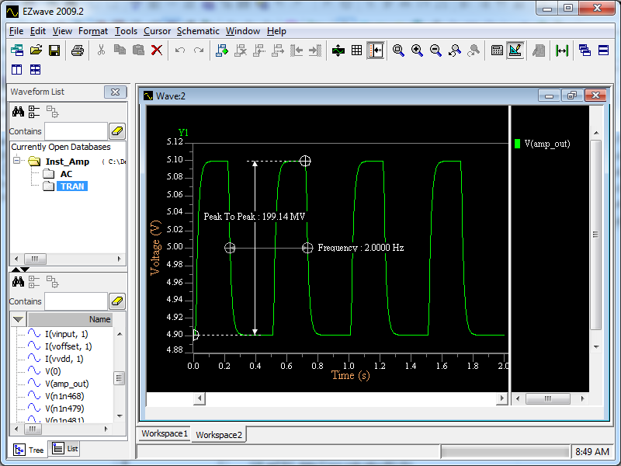
For more power, EzWave has a tutorial, see Help, Tutorial!
Hint: Select desired waveform and press this button to assign.
The measurement annotation can be selected and moved to view.
Select the Measurement type.

